Project GitHub Link:
https://github.com/Andran1k/SOSC314_CourseProject

Division of Responsibilities
For this project stage, each group member was responsible for the following components:

Andranik Pambukhchyan
Primary responsibility:
Data construction, cleaning, feature engineering, and corpus preparation.
Specific tasks completed this week:
- Extended the YouTube Data API data collection pipeline to support pagination, multi-region collection, and filtering to the Music category (scripts/fetch_youtube_trending.py)
- Implemented a reproducible processing script to construct the final text corpus from raw API output (scripts/build_processed_dataset.py)
- Defined the document unit as the combination of cleaned titles and descriptions and implemented text cleaning procedures (URL removal, whitespace normalization, tokenization)
- Engineered text-based and stylistic features, including token counts, lexical diversity, punctuation counts, capitalization ratios, and a binary outcome variable based on view counts
- Generated descriptive visualizations and bag-of-words summaries (unigrams and bigrams) to characterize the corpus (scripts/make_figures_week3.py)
- Ensured all outputs were saved in structured data/raw, data/processed, and figures directories for reproducibility

Asilbek Amonov
Primary responsibility:
Conceptual framing, measurement decisions, and documentation of preprocessing choices.
Specific tasks completed this week:
- Refined and justified key measurement decisions, including document definition, vocabulary scope, and filtering rules
- Assisted in defining which text features best capture stylistic and linguistic variation in trending music videos
- Reviewed exploratory summaries and figures to assess data quality and interpretability
- Contributed to drafting and revising the Week 3 written report, focusing on data construction, cleaning rationale, and planned analytical approaches

Overview
This stage of the project focuses on constructing a clean and analyzable text corpus from raw YouTube trending data. Building on the Week 2 feasibility assessment, we now document how the dataset is created, cleaned, and prepared for later text-as-data analysis. The goal of this stage is to transform raw API output into a structured corpus with well-defined document units and measurable text features, while clearly justifying all preprocessing decisions.
The project continues to focus exclusively on YouTube trending music videos, allowing for a more focused analysis of language use within a single cultural domain.
Raw Data Collection and Corpus Construction
Raw data are collected using the YouTube Data API v3, specifically the videos.list endpoint with the parameter chart=mostPopular. To increase coverage, data are collected using API pagination and across multiple regions, and then filtered to retain only videos labeled by YouTube as belonging to the Music category (category_id = 10).
Each raw dataset is saved as a timestamped CSV file in the data/raw/ directory to preserve reproducibility and allow tracking of data collection over time. Duplicate videos are removed based on video ID.
The unit of analysis remains one YouTube trending music video. For each video, we retain metadata fields such as view count and publication date, as well as textual fields used to construct the corpus.

Text Definition and Document Units
A key measurement decision in this project is the definition of a “document.” For each video, we define a document as the combination of the video title and description. This choice is motivated by the fact that titles alone are often very short, while descriptions provide additional contextual and promotional language.
The following text fields are created:
- title_clean: cleaned version of the video title
- description_clean: cleaned version of the video description
- document_clean: concatenation of the cleaned title and description
This document-level representation allows us to apply bag-of-words and other text-as-data methods consistently across observations.
Data Cleaning and Preprocessing Decisions
Several preprocessing steps are applied to prepare the text for analysis:
- Missing values: Missing titles or descriptions are replaced with empty strings to avoid dropping observations unnecessarily.
- URL removal: URLs are removed using regular expressions, as they do not contribute meaningful linguistic information.
- Whitespace normalization: Extra whitespace is collapsed to ensure consistent tokenization.
- Lowercasing and tokenization: Text is lowercased and tokenized using a simple regular-expression-based tokenizer that retains alphanumeric words.
Importantly, no stemming or lemmatization is applied at this stage. This decision preserves interpretability and keeps preprocessing minimal, allowing sensitivity checks in later weeks.
Descriptive Statistics and Data Characteristics
Basic descriptive summaries indicate that the processed dataset contains sufficient text for analysis. Titles are generally short but expressive, while descriptions vary widely in length and contribute most of the document text. Token counts and lexical diversity show substantial variation across videos, suggesting meaningful differences in language use.
Figure 1 illustrates the distribution of document lengths and confirms that the majority of videos contain enough textual material to support bag-of-words representations and frequency-based analysis.
Figure 2 shows the most frequently occurring single words (unigrams) in the cleaned titles and descriptions of YouTube trending music videos, highlighting the dominant vocabulary used in this category.
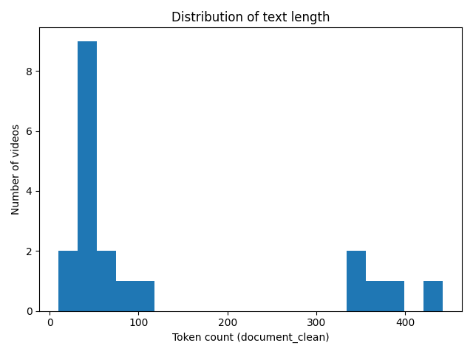
Figure 3 shows the most frequently occurring two-word combinations (bigrams) in the cleaned text, capturing common phrases and short expressions that appear repeatedly in trending music video metadata.
Figure 1
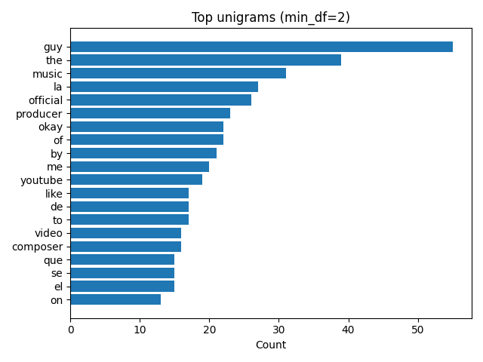
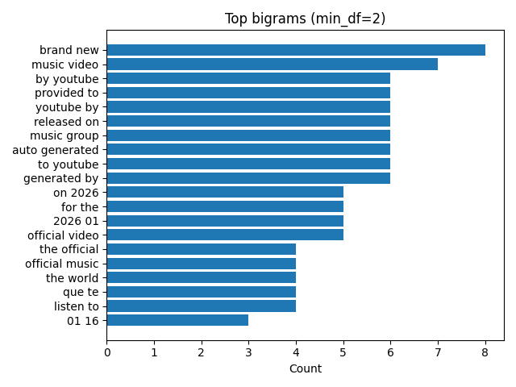
Figure 2
Figure 3

